HANDS-ON 3:Directives & Pipes — Built-in and Custom
Project Structure:
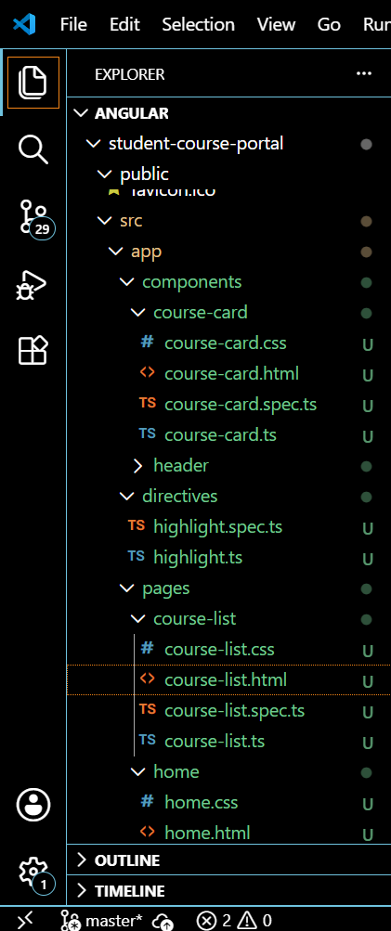
Highlight.ts
import { Directive, ElementRef, HostListener, Input } from '@angular/core';

@Directive({
selector: '[appHighlight]'
})
export class Highlight {
@Input() appHighlight = 'yellow';

constructor(private el: ElementRef) {}

@HostListener('mouseenter')
onMouseEnter() {
this.el.nativeElement.style.backgroundColor = this.appHighlight;
}

@HostListener('mouseleave')
onMouseLeave() {
this.el.nativeElement.style.backgroundColor = '';
}
}
Credit-label.ts
import { Pipe, PipeTransform } from '@angular/core';

@Pipe({
name: 'creditLabel'
})
export class CreditLabel implements PipeTransform {
transform(value: number | null | undefined): string {
if (!value || value <= 0) {
return 'No Credits';
}
if (value === 1) {
return '1 Credit';
}
return `${value} Credits`;
}
}
OUTPUT:
